Create SQL Database

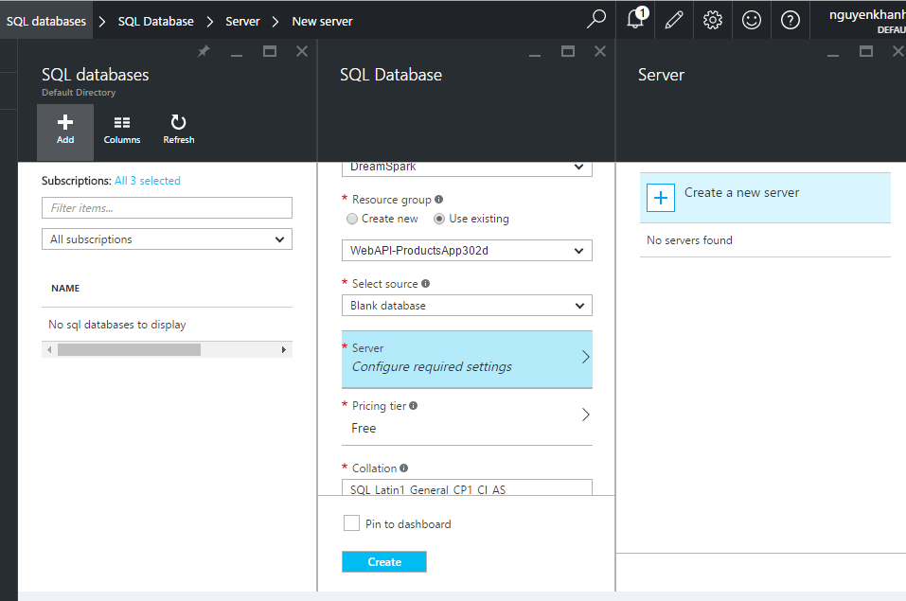

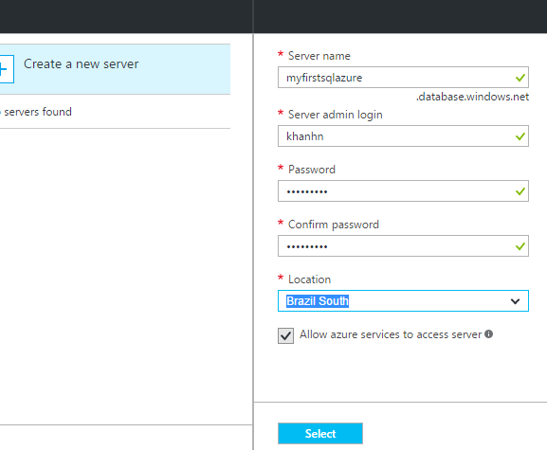

Khanhn/abc123!@#

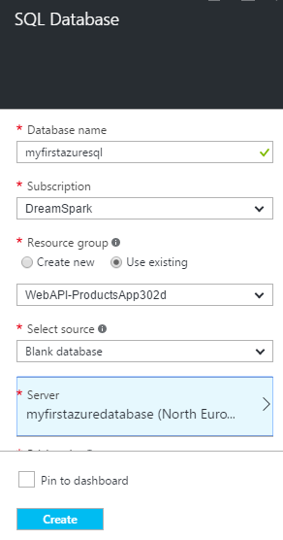

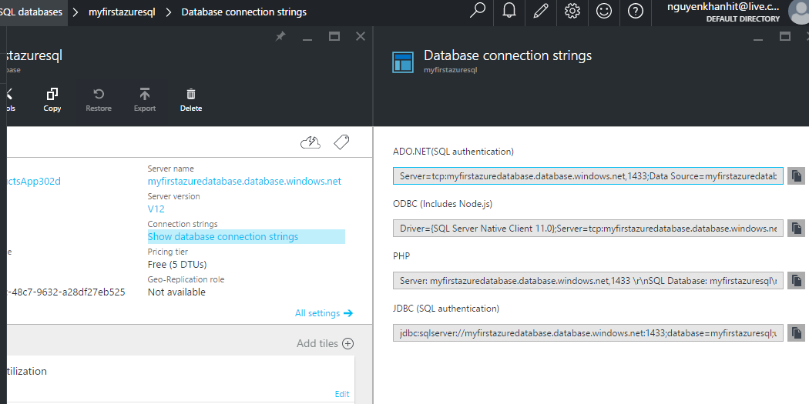

Server=tcp:myfirstazuredatabase.database.windows.net,1433;Data Source=myfirstazuredatabase.database.windows.net;Initial Catalog=myfirstazuresql;Persist Security Info=False;User ID={your_username};Password={your_password};Pooling=False;MultipleActiveResultSets=False;Encrypt=True;TrustServerCertificate=False;Connection Timeout=30;